**EDAWARE PATRICIA EWOMA-ZINO**

**179074012**

**CSC 831**

**Solving 8-Puzzle Game Using Steepest Ascent Hill Climbing Algorithm**

**Solving 8-Puzzle Game Using Steepest Ascent Hill Climbing Algorithm**

**The Problem Definition**

The puzzle consists of an area divided into a grid, 3 by 3 for the 8-puzzle. On each grid square is a tile, expect for one square which remains empty. Thus, there are eight tiles in the 8-puzzle. A tile that is next to the empty grid square can be moved into the empty space, leaving its previous position empty in turn. Tiles are numbered, 1 through 8 for the 8-puzzle, so that each tile can be uniquely identified.

The aim of the puzzle is to achieve a given configuration of tiles from a given (different) configuration by sliding the individual tiles around the grid as described above.

**Searching for a Solution**

This problem can be solved by searching for a solution, which is a sequence of actions (tile moves) that leads from the initial state to the goal state. Two possible states of the 8-puzzle are shown in fig 1. The state on the right is a typical goal state. The state on the left is a configuration that represents a worst case: transforming this state into the goal state requires at least 31 actions, which is the diameter of the search space. For search algorithms the problem is often to find the shortest solution, that is, one which consists of the least number of tile moves.

|  |  |  |
| --- | --- | --- |
| 8 |  | 6 |
| 5 | 4 | 7 |
| 2 | 3 | 1 |

|  |  |  |
| --- | --- | --- |
|  | 1 | 2 |
| 3 | 4 | 5 |
| 6 | 7 | 8 |

Fig 1: Configurations of the 8-Puzzle: worst-case initial state (left) for goal state (right)

**Detecting Solvable and Unsolvable 8 puzzle games**

In detecting if an 8 puzzle game is solvable, you need to determine if the number of inversions in the input state is even or odd. If it is even, the puzzle is solvable, else, if it is odd, it is unsolvable.

**What is inversion?**

A pair of tiles form an inversion if the the values on tiles are in reverse order of their appearance in goal state.

|  |  |  |
| --- | --- | --- |
| 1 | 2 | 3 |
| 4 |  | 5 |
| 7 | 8 | 6 |

|  |  |  |
| --- | --- | --- |
| 1 | 2 | 3 |
| 4 |  | 6 |
| 8 | 5 | 7 |

Inversions = 3 inversions = 2

(6-5 8-5 8-7) (8-6 7-6)

Unsolvable Solvable

Fig. 2

**What Are Heuristics?**

Heuristics are rule of thumb. They are a quick way to estimate how close we are to the goal. That is, how close is a state to the goal.

For the 8-puzzle game, we can use either number of misplaced tiles or Manhattan distance to calculate the heuristic value.

**Manhattan Distance**

For my work, Manhattan distance will be used in calculating the heuristic value. Board configuration with the minimum Manhattan distance will be evaluated further, once Manhattan distance becomes zero (0), it means the goal state has been reached.

Manhattan distance is the sum of the absolute differences of the coordinates.

The Manhattan distance between two points is defined as:

D(M,P) = |MZ -PZ| + |MY-PY|

For example,

if x=(a,b) and y=(c,d), the Manhattan distance between x and y = |a-c|+|b-d|

Let’s consider two 8-puzzle board configuration below, one is the start state and the other is the goal state. the heuristics can be calculated using number of misplaced tiles or Manhattan distance.

|  |  |  |
| --- | --- | --- |
|  | 1 | 2 |
| 3 | 4 | 5 |
| 6 | 7 | 8 |

|  |  |  |
| --- | --- | --- |
| 7 | 2 | 4 |
| 5 |  | 6 |
| 8 | 3 | 1 |

Start State Goal State

Fig. 3

h1(n) = Number of misplaced tiles

h2(n) = Manhattan distance

In fig. 3 above:  
h1(s) = 8

h2(s) = 3+1+2+2+2+3+3+2 = 18

**Steepest Ascent Hill Climbing(Gradient Search)**

It is a variant of Hill climbing algorithm. It can be implemented by having a slight modification to the simple hill climbing algorithm. In this algorithm, we consider all possible states from the current state and then pick the best one as successor, unlike in the simple hill climbing technique whereby, any state which was closer to the goal than the current state was chosen as the successor.

**Steepest ascent Hill climbing algorithm**

1 Evaluate the start state

2 If it is goal state then quit

otherwise make the current state this start state and proceed;

3 Repeat Until a solution is found or current state does not change

3.1 Set target to be the state that any successor of the current state can better;

3.2 For each operator that can be applied to the current state

3.3 Apply the new operator and create a new state

3.4 Evaluate this state

3.5 If this state is goal state then quit

3.6 Otherwise compare with target

3.7 If better set target to this value

3.8 If target is better than current state set current state to target

**8-Puzzle using steepest ascent hill climbing algorithm -- how it operates.**

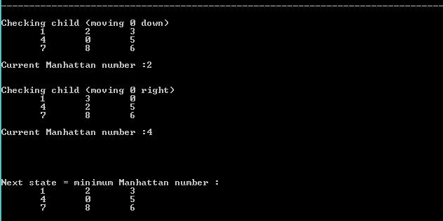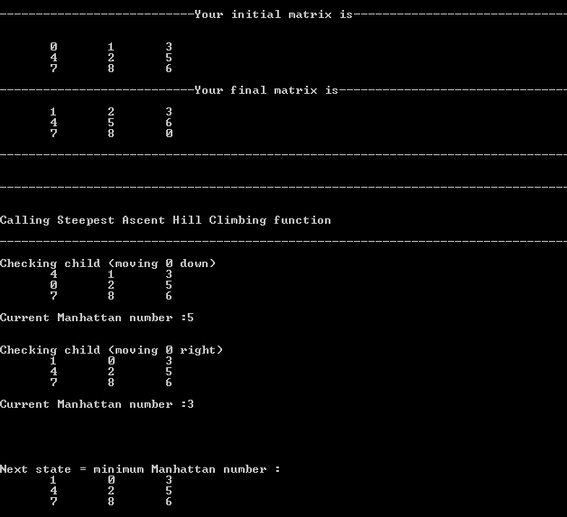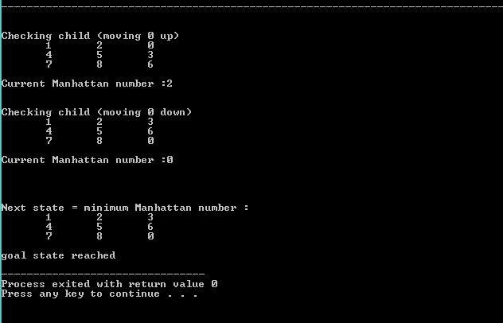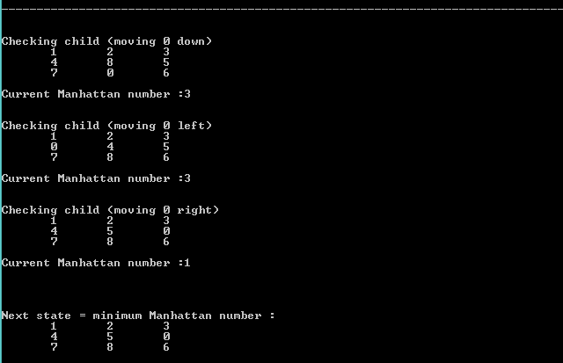

**References**

Geeks for Geeks. How to check if an instance of 8 puzzle is solvable? Retrieved from <https://www.geeksforgeeks.org/check-instance-8-puzzle-solvable/> on 2 May 2018.

Xavier D.(2006) Manhattan distance of a point and a line. Retrieved from <http://artis.imag.fr/~Xavier.Decoret/resources/maths/manhattan/html/> on 2 May 2018.

Kalev K.(2014) Informed Heuristic Search.

The 8-Puzzle. Retrieved from <http://www.aiai.ed.ac.uk/~gwickler/eightpuzzle-inf.html> on 2 May 2018.